**DAILY ONLINE ACTIVITIES SUMMARY**

|  |  |  |  |  |  |  |  |  |
| --- | --- | --- | --- | --- | --- | --- | --- | --- |
| **Date:** | **09-06-2020** | | | | | **Name:** | **Anusha** | |
| **Sem & Sec** | **VIII Semester & A Section** | | | | | **USN:** | **4AL16CS014** | |
| **Online Test Summary** | | | | | | | | |
| **Subject** | | **BDA** | | | | | | |
| **Max. Marks** | | **30** | | **Score** | | | **25** | |
| **Certification Course Summary** | | | | | | | | |
| **Course** | **Introduction to Hadoop & Robotic Process Automation** | | | | | | | |
| **Certificate Provider** | | | **Great Learning & Ui Path** | | **Duration** | | | **4 Hours & 3 Hours** |
| **Coding Challenges** | | | | | | | | |
| **Problem Statement: To display first N triangular numbers.** | | | | | | | | |
| **Status: COMPLETED** | | | | | | | | |
| **Uploaded the report in Github** | | | | | **YES** | | | |
| **If yes Repository name** | | | | | **anushasuvarna-14** | | | |
| **Uploaded the report in slack** | | | | | **YES** | | | |

Online Test Details:

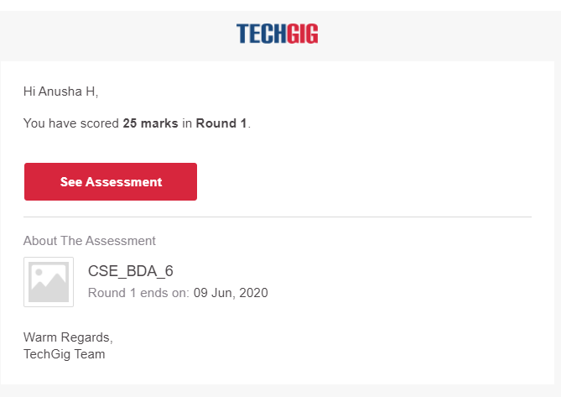

Certification Course Details:



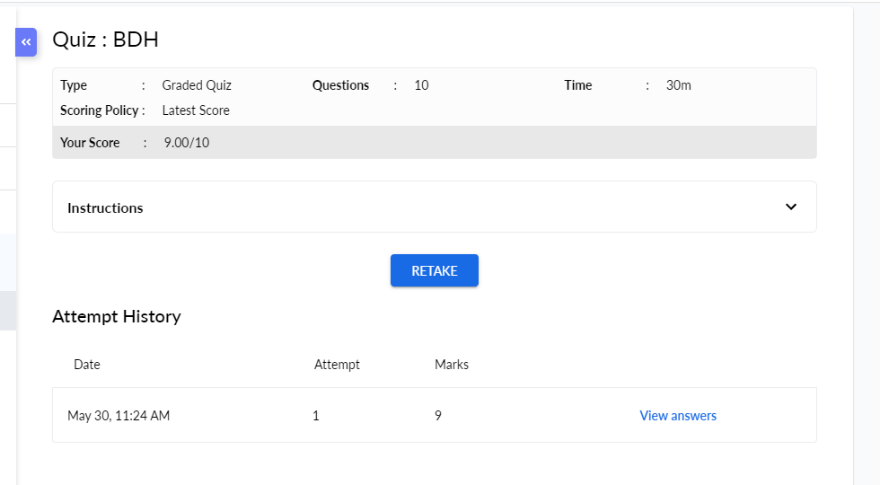

Coding Challenges Details:

|  |
| --- |
| **#include<stdio.h>** |
|  | **void triangular_series(int n)** |
|  | **{** |
|  |  |
|  | **for (int i = 1; i <= n; i++)** |
|  |  |
|  | **printf(" %d ", i*(i+1)/2);** |
|  | **}** |
|  |  |
|  | **int main()** |
|  | **{** |
|  |  |
|  | **int n ;** |
|  | **printf("Enter value for n");** |
|  |  |
|  | **scanf("%d",&n);** |
|  |  |
|  | **triangular_series(n);** |
|  |  |
|  | **return 0;** |